ML Major 2

Submitters:
Husain Azaqy: 213382104
Galor Lazar: 325028876

(Q1) Train a k-NN model using k = 1 on your training set and use the visualize_clf method to visualize the resulted decision regions (with appropriate title and labels).
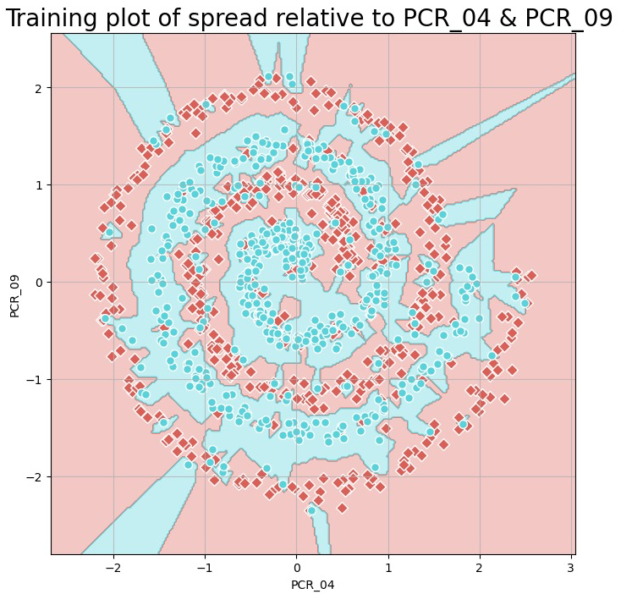

(Q2) Answer: Which k is the best? What are its average training and validation accuracies (estimated by cross-val.)? Which k values cause overfitting and underfitting and why?
We choose the best k by finding the k that provides the best validation accuracy because the validation error is close to the classifier error. The best k for predicting the spread class using PCR_04 and PCR_09 is k=11 with average training and validation accuracy 84%.
We know that overfitting is when the model performs very well on the training data but not well on the validation because the model is complex and modified too well on the training data and the noise it includes. We can see that in k =1 where the Training accuracy is 100% but the validation data accuracy is 72.2%.
Underfitting occurs when the model tries to be too general and tries to find too many neighbors that may be far away from the original point location. By this, the model gets in both training and validation datasets a very low accuracy. We can see that in the k’s that are greater than 85, that have both training and validation datasets a very low accuracy.
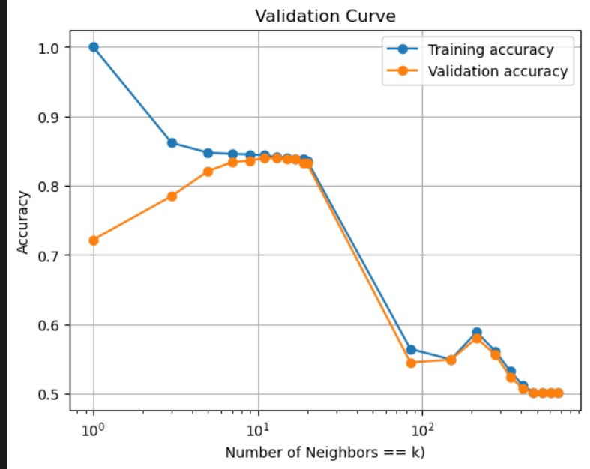
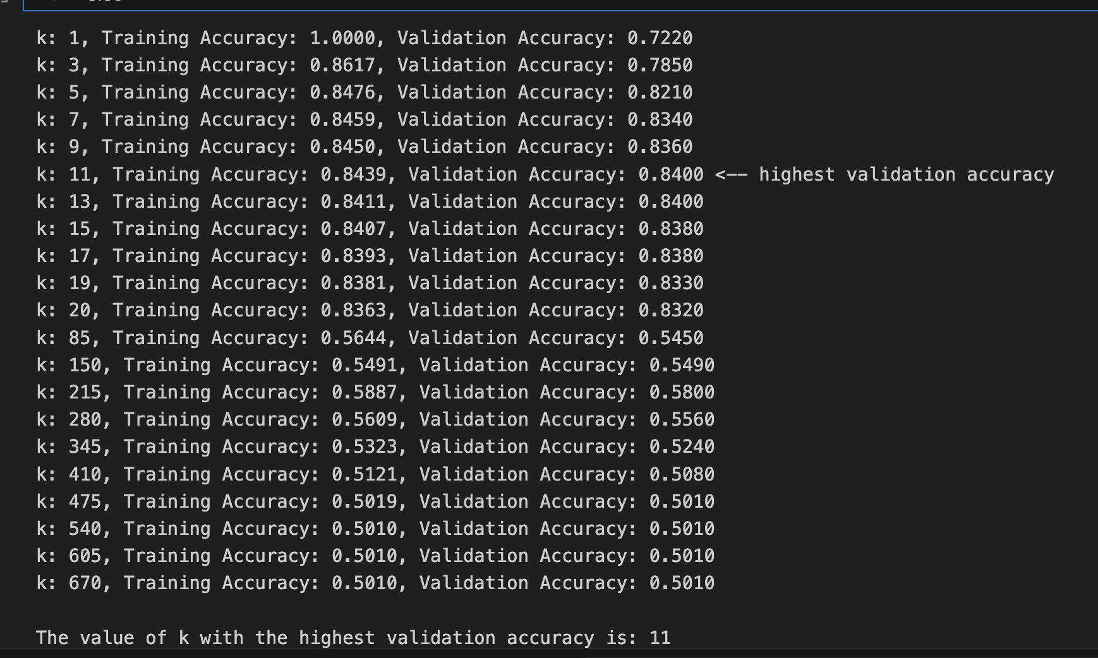

(Q3) Use the optimal k value you found and retrain a k-NN model on all the training samples. In your report: plot the decision regions of this final model (using visualize_clf) and write its test accuracy (computed on the separate test split) of this model.
For k=11 :
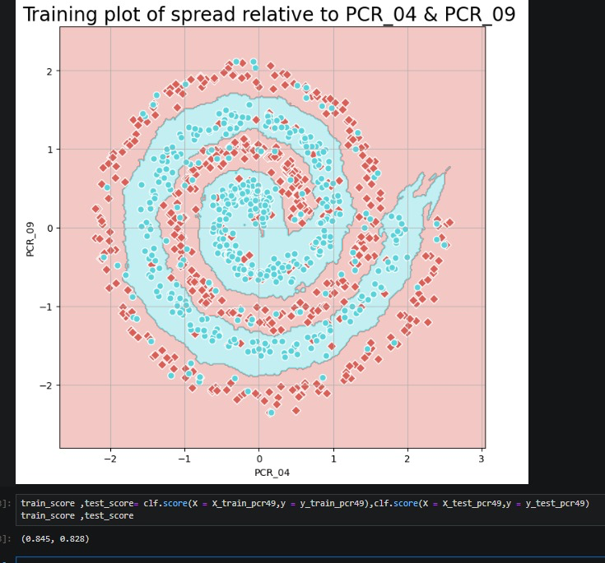
Training accuracy score: 84.5%
Test accuracy score: 82.8%

(Q4) Compare the boundaries of the two models you have trained in (Q1) and (Q3). Discuss the results and the exhibited behaviors (2-3 sentences).
Comparison between k=1 to k=11:
As we can clearly see, the k=11 graph is much smoother and less sensitive for outliers, which gives us much better performance, and it's due to the fact the model uses 11 nearest neighbors to predict the label. Unlike the k=11, the k=1 model uses only one neighbor, in it’s graph we can see many different small areas of color changing around single points that may count as outliers in the real dataset. That happens because this time the model uses only the 1 nearest neighbor for the predictions and doesn’t generalize it by checking the data and the area that the point itself found in.

(Q5) Train a model with ID3 and max_depth=3 (not including the root level; use the entire training set, i.e., all the features after preprocessing from all the training samples). What is the training accuracy? Visualize the trained tree using plot_tree (provide feature and class names; use filled=True) and attach the plot to your report. The plot should be readable!

The training accuracy is 69.5%
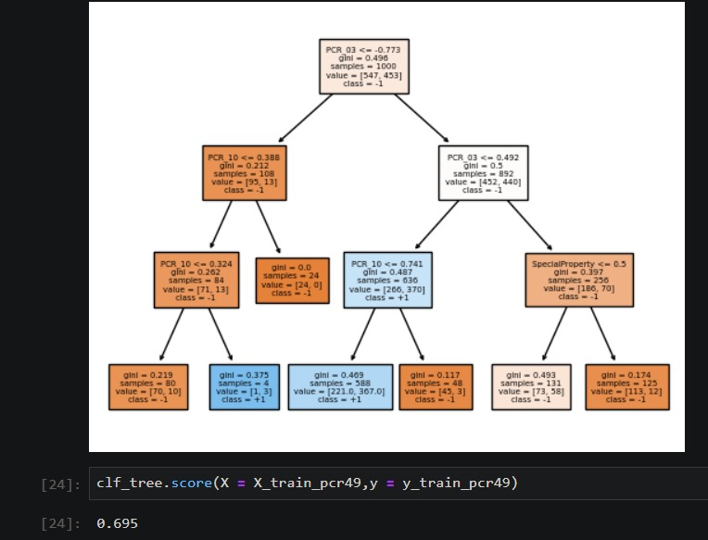

(Q6) Using 5-fold cross-validation, tune the two hyperparameters by performing a grid search (see GridSearchCV). Find the combination yielding the best validation error for predicting the risk class. You should:
a.Choose appropriate ranges for both hyperparameters. This may require a few attempts. To make things quicker when trying to find appropriate hyperparameter ranges, you can start by using only 2 folds.
Our ranges:
b. Since we tune two hyperparameters, instead of a validation curve, plot two heatmaps (seaborn / pyplot), for each of the cross-validated training and validation accuracy (the heatmaps should roughly look like the ones to the right). Plot the appropriate “ticks” on both axes and use annotations (annot=True) to explicitly write accuracies inside heatmap cells. Important: The plots should be readable and informative!

c. Add the 2 plots to your report and specify which hyperparameter combination is optimal.

d. Write a hyperparameter-combination that causes underfitting.

e. Write a hyperparameter-combination that causes overfitting.

f. Add a short discussion regarding why each specific hyperparameter-combination from sub-questions 'd' and 'e' resulted in under/over-fitting.

